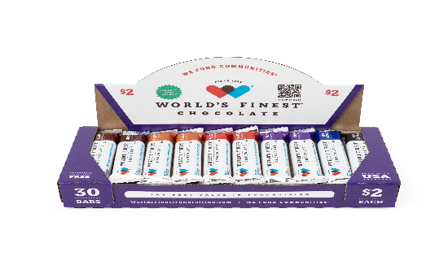BETHEL Elementary School PTO

2025 Fall Fundraiser

**T**he funds we raise from this fundraiser are going to help us support our teachers throughout the year for **instructional supplies, classroom materials and to enrich our student's educational experience!**

**You can make the difference!** Please **support Bethel Elementary School** by checking out at least one box of WFC and helping your child sell the chocolate to family, friends, co-workers and businesses.

Sale Begins: Tuesday, August 26th

Sale Ends: Tuesday, September 16th

All Prizes are cumulative (the more you sell, the more prizes & cash you earn) and based on **ALL** money due, being turned in no later than Tuesday, September 16th.

Student Incentives: There will be lots of really cool prizes, Chick Fil A cards and you can even get out of class to attend a Pig Race & Ice Cream Party! All prize information will go home Tuesday, August 26th!

If you find a Golden Ticket inside your box of chocolate, turn in your $60 along with the Golden Ticket and you win a **1-pound World’s Finest Chocolate Bar!**

---------------------------------- **Cut off below and return to school** ------------------------------------

**Chocolate Check-Out Form**

**All Chocolate must be paid for before additional Chocolate may be checked out**

I would like to check out **1 box of 30 $2.00 WORLD’S FINEST CHOCOLATE BARS** **($60/Box**) andhelp **Bethel Elementary School PTO raise needed funds to support our teachers.** I understand I am responsible for the chocolate, including eaten, stolen or lost chocolate and turning **$60** into the school no later than **Tuesday, September 16th**.

**NO Chocolate can be returned once it is checked out.**

**Parents: please help us!** Please replace all small bills and change with larger denominations such as **$10 OR $20 BILLS or a check made out to Bethel Elementary School PTO! THANK YOU!**

**STUDENT’S NAME:**_________________________________________**TEACHER:**_____________________

**PARENT’S SIGNATURE:**___________________________________________________________________

**PHONE #:**________________________**EMAIL:**________________________________________________