2021 HAYWOOD COUNTY SCHOOLS FOUNDATION SCHOLARSHIP CHECKLIST
Print out and add page to the front of your application with scholarships you are applying for checked.

STUDENT NAME: STUDENT SCHOOL:
OPEN TO ALL STUDENTS
- Altrusa International of Waynesville
- Bill Sease Memorial
- B. L. Upton, Sr. and D. E. Tingle Memorial
- Bobbie W. Harpe Memorial
- Champion Credit Union-Roland Leatherwood
- Clyde Lions Club-Somberg, McCracken & Hannah
- Cynthia Shepherd Culbertson Memorial
- Dr. Alan & Rita M. Brown Memorial
- Dr. Kristen Hammett-Vet-Tech
- Dr. Mack S. & Beulah Setser
- First Citizens Bank
- Frank & Kathryn G. Kirkpatrick Memorial
- Haywood County Realtor Association
- Haywood County Community Band
- Haywood County Democratic Women
- Haywood County Fraternal Order of Police
- Haywood County Retired School Personnel
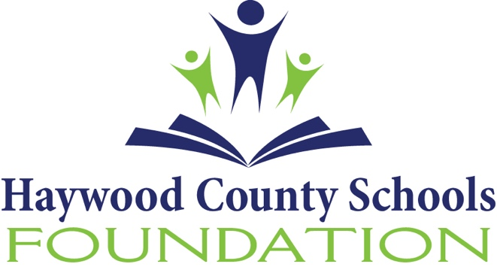
- Haywood County Schools Foundation
- Haywood County Schools Nutrition Association
- Haywood Healthcare Foundation
- Kinsland Family Scholarship
- Junaluska Ross-Lance
- Lake Junaluska Servant Leader
- Machesney Computer Science
- Moses L. Robinson Memorial
- Patricia C. Liner, RN Memorial
- Peggy Melville
- Pepsi-Cola Bottling Co. of WNC-Vocational
- Posey Family
- QuickDraw-Art
- Ray Foster OCS Memorial
- Reeves Memorial
- Reuben B. Robertson Foundation
- Richie's Alliance
- Robert E. & Viola Forga
- Scott Sisters
- Sharon H. Blankenship A.E.O.P.
- Shay Barnes Starnes Memorial
- Smathers Cruso
- State Employees Credit Union
- Teresa Kaye Ashe Memorial for Nursing
- Tom Cifani Memorial Music Scholarship
- Tommy E. Davis Memorial
- United Community Bank
- Waynesville Garden Club-Horticulture
- WOW - Lynda Chovan Memorial

HAYWOOD EARLY COLLEGE ONLY
- Waynesville Masonic Lodge

PISGAH HIGH SCHOOL ONLY
- Adeline B. Patrick Memorial
- Betty Jean Henson Memorial
- Black Orthodontics
- Canton High School Class of 1957
- Chapman, GE Aviation Memorial
- Cruso Friendship Club Jervis/Alexander
- Doris Plott Memorial
- Gene Haas Foundation
- Haywood Rotary Club
- James M. and Mary P. Edwards Memorial
- Jeff Simmons Memorial
- Justin Inman Memorial
- Ladies Lunch Bunch Pisgah Class of 1968
- Mary Gillis Educational Memorial
- Master Trooper Calvin E. Taylor Memorial
- Paul Willis JROTC Memorial
- PHS Golden Anniversary
- Plott Memorial
- Sonoma Masonic Lodge
- Sportsman's Club
- Staff Sargent Michael C. Parrott Memorial

TUSCOLA HIGH SCHOOL ONLY
- Adeline B. Patrick Memorial
- Black Orthodontics
- Buddy Chandler Scholarship
- Charles K. Patterson
- David Sherrill Memorial
- Dustin Travis Moody Memorial
- Elayne Tucker Wadsworth
- James & Betty Scott Memorial
- John C. Howell Memorial
- Mark Douglas Parris Memorial
- Paul Willis JROTC Memorial
- Sportsman's Club
- Steve Sutton Memorial
- Trooper Anthony Cogdill Memorial
- Tuscola Class of 1971
- Tuscola Class of 1972
- Tuscola Class of 1973
- Tuscola Class of 1984
- Waynesville Lions Club-Charles Balentine Sr.
- Waynesville Masonic Lodge
- Waynesville Rotary-Howard Splitt Memorial
- Waynesville Woman's Club

CENTRAL HAYWOOD HIGH SCHOOL ONLY
- Betty Jean Henson Memorial
- Nick Mastriana Memorial
- Reeves Family Scholarship
- Sonoma Masonic Lodge
- Waynesville Masonic Lodge

